|  |
| --- |
| **BAHRIA UNIVERSITY (KARACHI CAMPUS)**    Open Ended Lab 1 – SPRING SEMESTER – 2020    **(Software Design and Architecture - SEL457)**    Class: **BSE 4A** (Morning)  Course Instructor: **Engr Muhammad Rehan Baig**  Max Marks: 15    **Student’s Name**: **OBAID UR REHMAN** **Reg. No:** **57294**  **Enrollment numb : 02-131182-083**  **[CLO 4]** |

**SCENERIO:**

USA based marketing agency want to develop web based application for automate their marketing strategies. An application contains following modules.

* Registration/Authorization(Signup/Login) • Scheduled based Ads posting on defined websites.
* Content Management System.
* Accounting Module for Ads that hourly calculate and charge clients.
* REST Api’s for other devices to connect.

**Q1 Design** Data flow Diagram, Class Diagram and ERD diagram for the given Scenario.

**[7 marks]**

**FLOW CHART DIAGRAM**

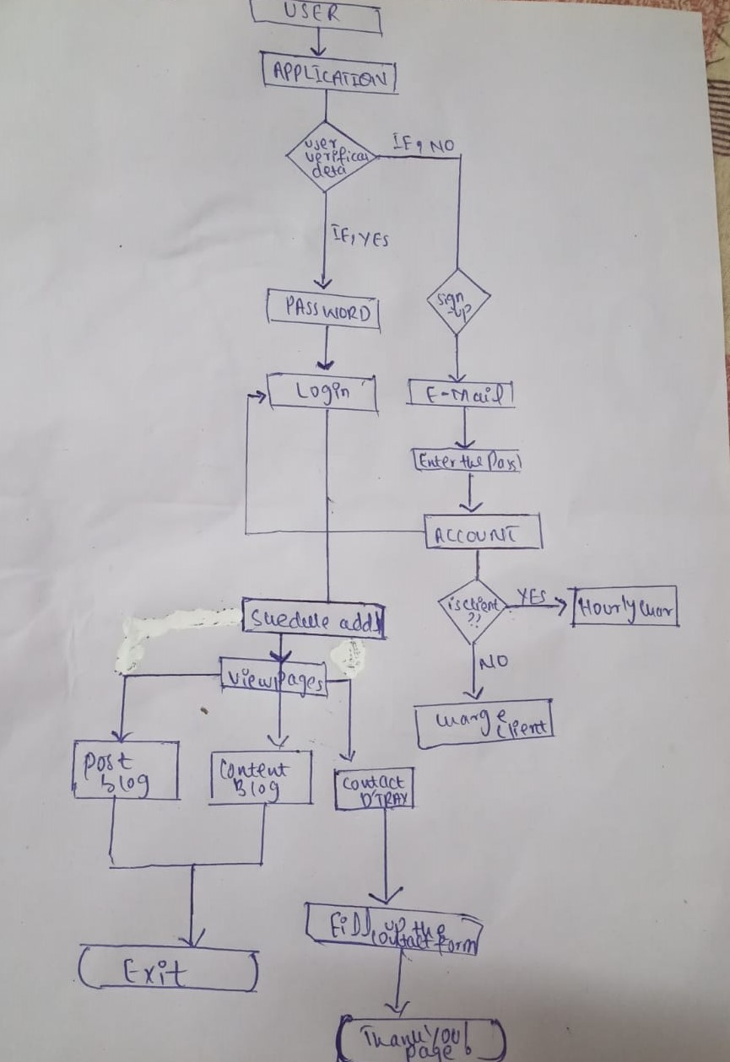**CLASS DIAGRAM:**

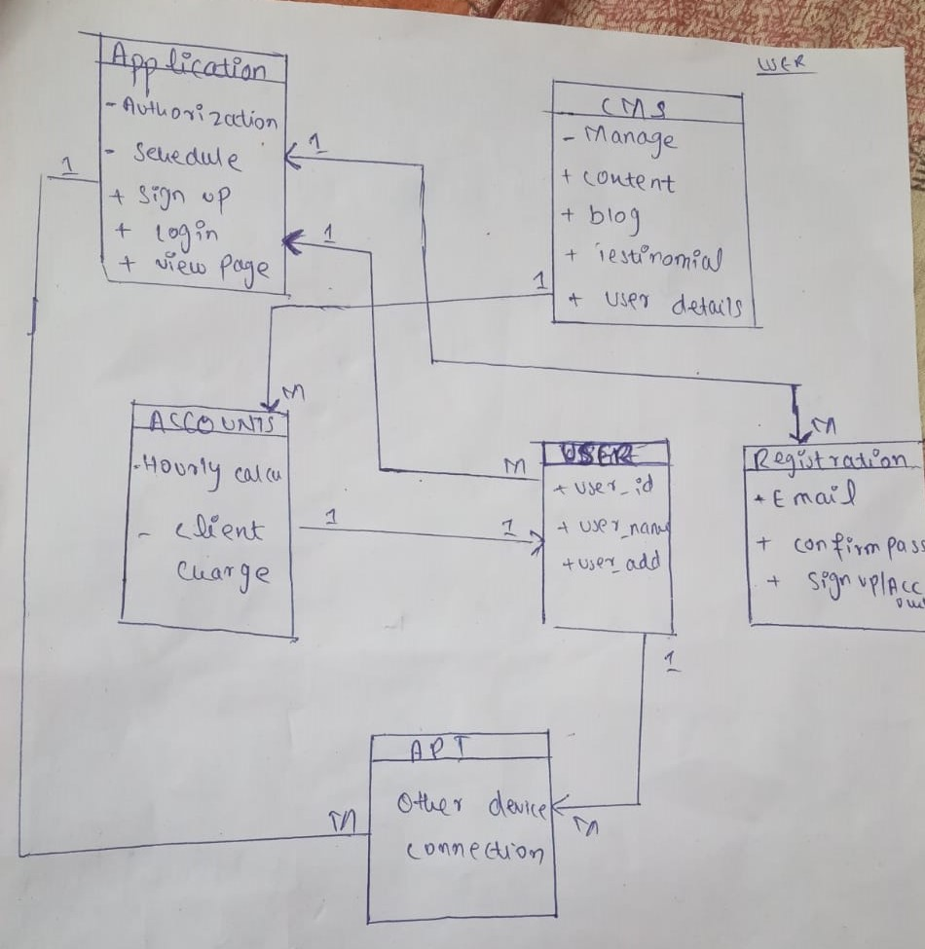

**ERD :**

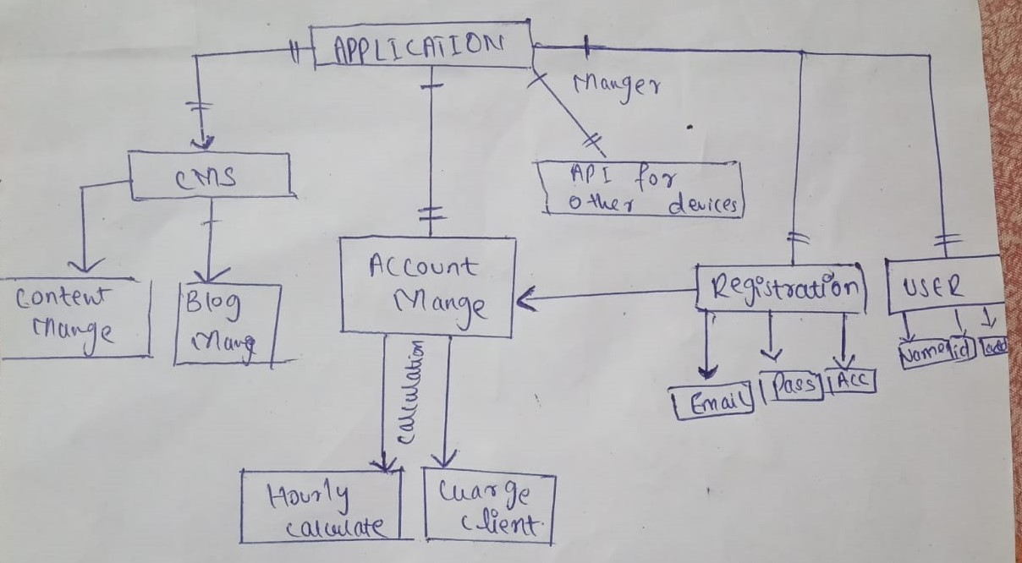

**Q2 Identify** and **Implement** best suited design patterns for the given scenario (**Note**: Multiple

Design patterns can be implemented) **[8 marks]**

**ANSWER**

1. **We use factory design pattern for cms ….**

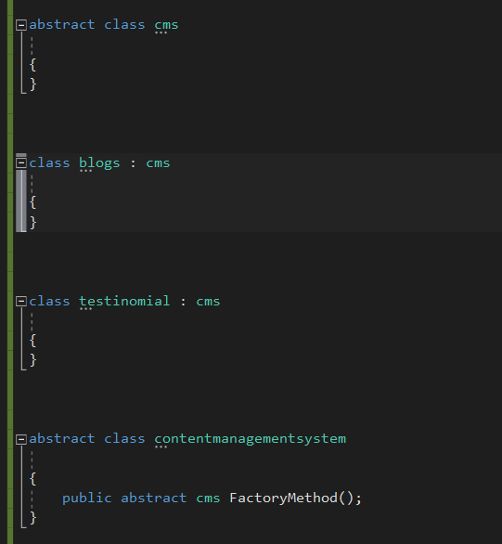

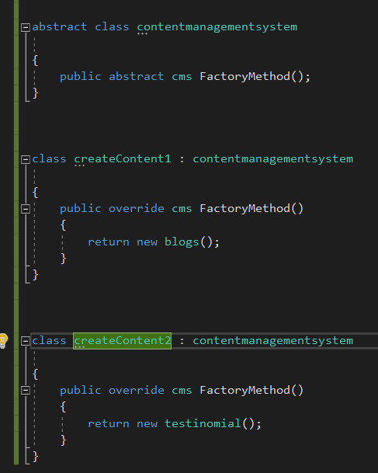

1. **We use singleton design pattern for registration..**

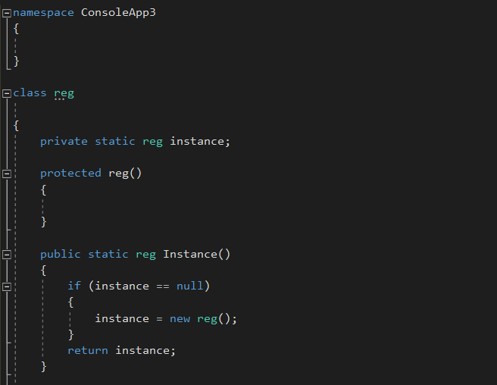

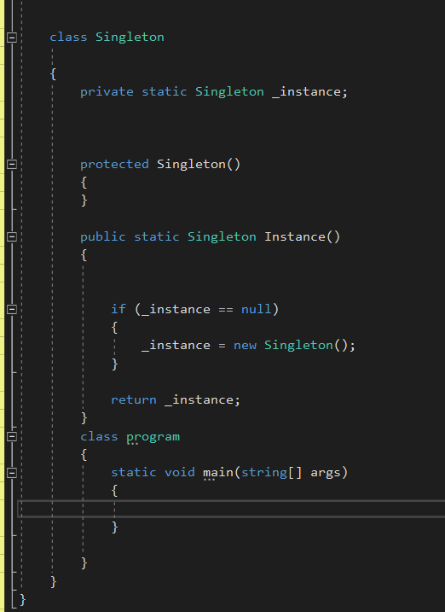

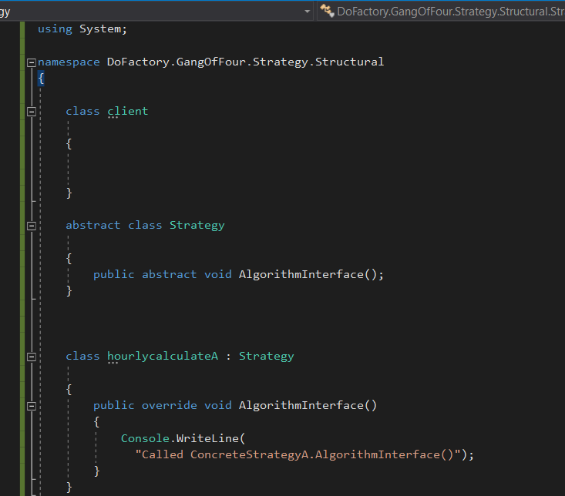

1. **We use adapter design pattern for REST API …**

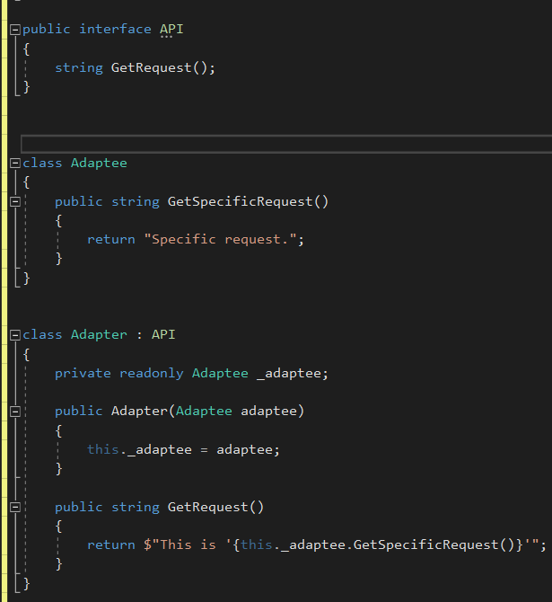

1. **We use composite design pattern for schedule ….**

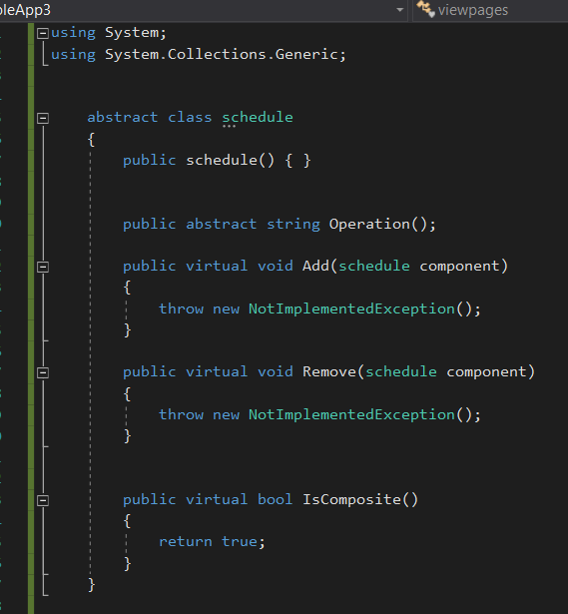

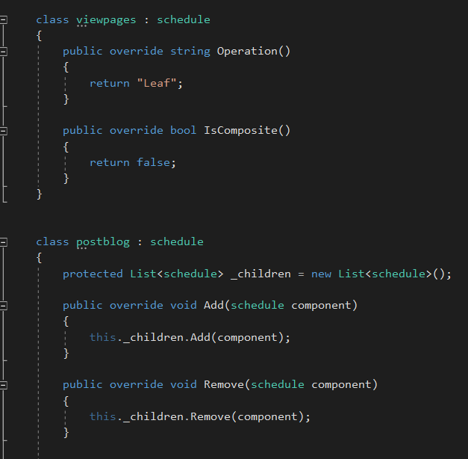

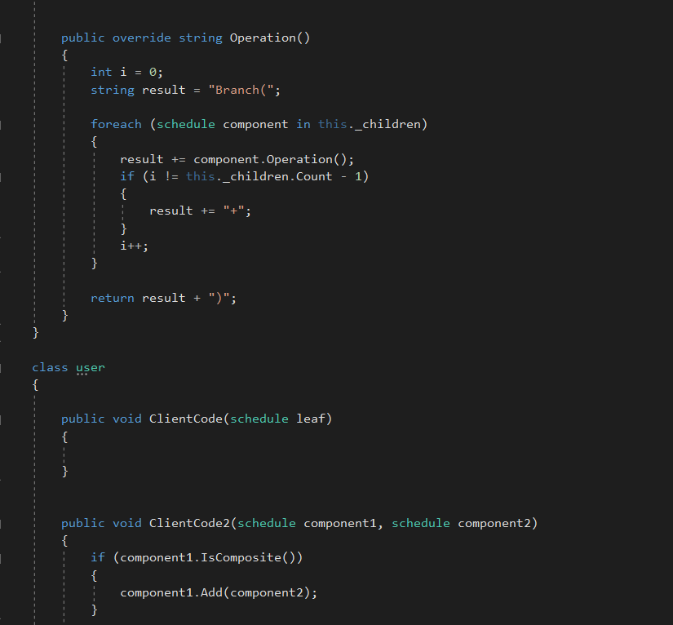

**5. Accounting module for ads that hourly calculate and charge clients that’s why we use strategy pattern…**

